**Windows Fundamental**

**Introduction**

The module kicks off with a refresher course on Windows operating system - it is important to have knowledge of a wide variety of technologies. A thorough understanding of Windows is followed thereafter in a wide range of assessment types.

The goal of the learner in this module is to:

* Understand the architecture and components of the Windows operating system.
* Learn basic file system navigation and command line usage.
* Gain familiarity with Windows security features, user accounts, and permissions.
* Configure and utilize basic networking tools and services in Windows.

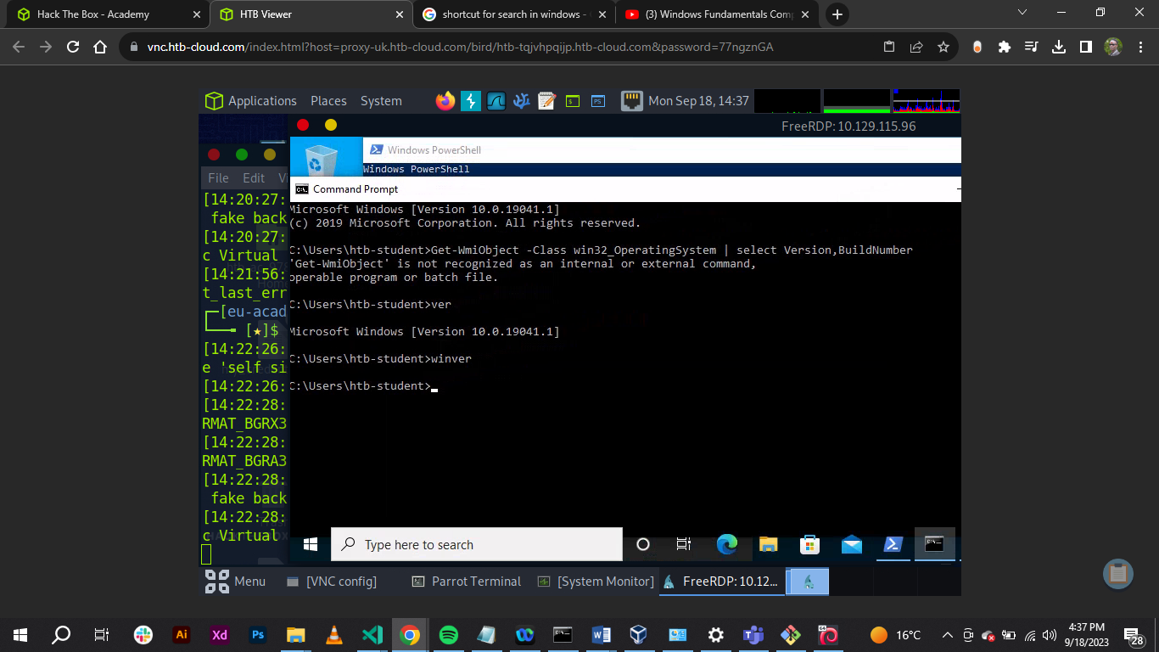 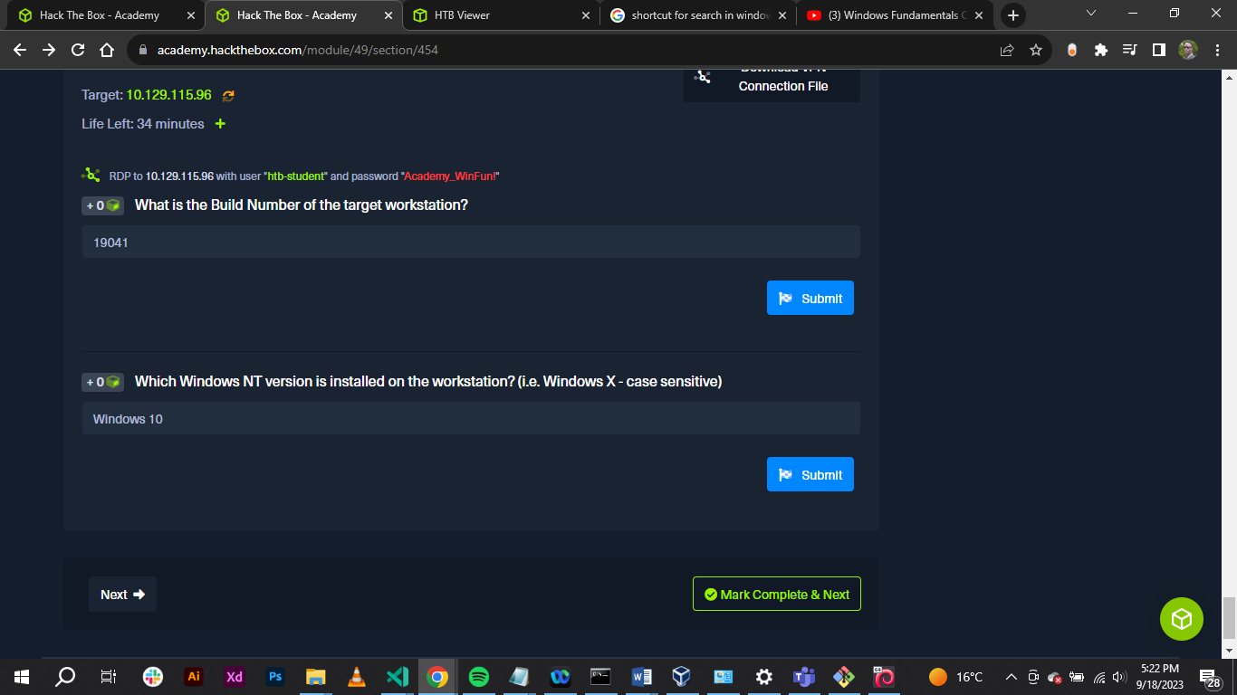

**Conclusion**

In this section I was able to access a remote desktop using **xfreerdp** tool on Parrot terminal.

It is (xfreerdp) is a tool that remotely access Windows targets run on Linux – based attack host.

The learner understood the architecture and components of the Windows operating system and learnt basic file system navigation and command line usage.